wk1_assign_B_php.doc

Topic: Working with FORMS and Variables

Description: *“Display a Customized Greeting to a User”*

Task #1: Create the Form “nameform.htm”

* Open your text editor;
  + The <title> tag should say “Customized Greeting – by [your name here!]”
  + Use the POST method and call the “greeting.php” page when the form is submitted.
* 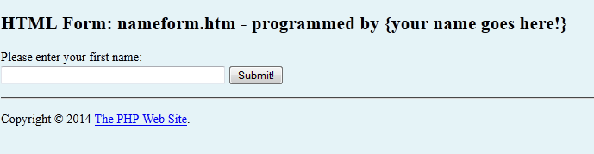Create the document as shown below;

Modifications to the form:

* + Notice the Copyright information.
    - Display the © symbol (HTML)
    - Display the year as 2014
    - Change the text link www.php.net
  + Save the document as: nameform.htm

Task #2: Create the “greeting.php” page

*When the form is submitted, greeting.php is executed and passed the value of the firstname parameter from the form.*

* Open your text editor;
  + The <title> tag should say the text “Greetings, [your name here!]”

* + The message on the page should also contain the name entered into the form field, using server-side script.

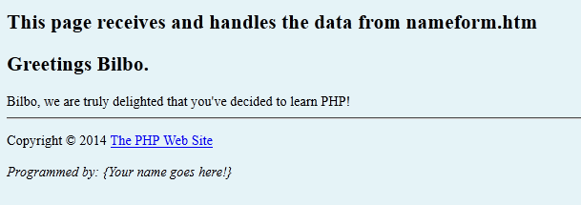

*** Display the value received from the web form here! ***

* When the form is submitted, the following page is displayed;
  + Save the document as: greeting.php
* Post file *nameform.htm and greeting.php to the college* server and TEST!

wk1_assign_B_php1.doc